**EE 602 Part-2**

**Contents**

1. **What is Radar?**
   1. Basics of Radar
   2. Radar Block Diagram
   3. Range and Velocity Measurement for Pulsed Radars
   4. Propagation of Radar Signals
   5. Applications of Radar Technology
   6. Deriving Radar Parameters from User Requirements
   7. Numerical problems
2. **Understanding Radar Design parameters** 
   1. The Radar Equation
   2. Receiver Sensitivity and Detection of the Signal in Noise
   3. Signal to Noise Ratio, Noise Figure of single and Cascaded Modules
   4. Probability of Detection and False Alarm
   5. Radar Cross-Section
   6. System Resources: Power Aperture Product
   7. Numerical problems
3. **Continuous Wave Radars**
   1. Continuous Wave radar and its applications
   2. Linear FMCW Radars
   3. Range and Doppler Measurement in FMCW radars
   4. Isolation Between Transmitter and Receiver
   5. Applications of FMCW Radars
   6. Numerical problems
4. **Transmitters, Duplexers and Circulators**
   1. Types of RF and microwave sources
   2. Sources for Terahertz frequencies, Sodars and Lidars
   3. Phase Noise considerations
   4. Duplexers and Circulators
   5. Numerical problems
5. **Antennas used in Radar Systems** 
   1. Antenna Radiation Pattern
   2. Effect of Aperture Illumination
   3. Array Antennas
   4. Beam steering: mechanical and electronic
   5. Digital beam forming
   6. Applications
   7. Numerical problems
6. **Receivers**
   1. Receiver Protection
   2. Matched filter detection
   3. Types of radar receivers
   4. Digital receivers
   5. Pulse compression
   6. Signal enhancement techniques
   7. Numerical problems
7. **Radar Target Tracking** 
   1. Tracking with Radars
   2. Conical Scan Sequential Lobing
   3. Monopulse tracking receivers
   4. Tracking Accuracy
   5. Numerical problems
8. Navigational and Strategic applications of Radars
   1. Secondary radars: DME VoR and ILS
   2. Radar Beacons
   3. OTH radars
   4. Early warning radars
   5. Synthetic aperture radars
   6. Passive bi-static radars
   7. Jamming, ECM and ECCM
   8. Example of countermeasure technique for FMCW radar
   9. Numerical problems
9. Digital realization of radar sub-systems
   1. Need for sub-system realization using digital components
   2. Numerically controlled oscillator (NCO)
   3. Direct digital Synthesis
   4. Digital down converter (DDC)
   5. Cascaded Integrator Comb filter (CIC) and usage
   6. Numerical problems

**References**

1. M.I.Skolnik, Introduction to Radar Systems, McGraw Hill, 1980.
2. D.K.Barton, Modern radar systems analysis, Artech House, 1988.
3. B,Edde, Radar: Principles, Technology, Applications, Prentice Hall, 1993.
4. [Mark A. Richards](https://www.amazon.com/Mark-A.-Richards/e/B005WWKUH4/ref=dp_byline_cont_book_1) (Ed.), [James A. Scheer](https://www.amazon.com/s/ref=dp_byline_sr_book_2?ie=UTF8&text=James+A.+Scheer&search-alias=books&field-author=James+A.+Scheer&sort=relevancerank) (Ed.), [William A. Holm](https://www.amazon.com/s/ref=dp_byline_sr_book_3?ie=UTF8&text=William+A.+Holm&search-alias=books&field-author=William+A.+Holm&sort=relevancerank) (Ed.), **‘**Principles of Modern Radar: Basic Principles,’**Scitech Publishing Inc,** 2015, ISBN-13: 978-1891121524, ISBN-10: 1891121529
5. Hugh D. Griffiths (Editor), Christopher Baker (Editor), David Adamy (Editor), ‘Stimson's Introduction to Airborne Radar (Electromagnetics and Radar)’, ’Scitech Publishing Inc, 3rd Edition, ISBN-13: 978-161353022, 1ISBN-10: 1613530226
6. William L. Melvin (Editor), James A. Scheer (Editor), Principles of Modern Radar: Radar Applications Har/Psc Edition ’Scitech Publishing Inc, 2014, ISBN-13: 978-1891121548 ISBN-10: 1891121545

**Chapter-4**

**Transmitters, Duplexers and Circulators**

In this chapter we shall have a brief look at the transmitters used in the radars. The radar transmitter consists of multiple electronic modules, often collectively referred as ‘transmitter system’. A schematic diagram of a transmitter system is shown in Fig. 4.1.

2. Phase locked Oscillator(s)

1. Reference Oscillator

3. Modulator

4. Frequency Up-convertor(s)

5. Power Amplifier

6 Harmonic Filter(s)

**To Antenna**

(Through switching/ routing units like duplexer/ circulator etc.)

Fig. 4.1 Typical configuration of a radar transmitter system

A brief description of each of the system is as follows:

1. **Reference Oscillator**: Radar operated at a particular frequency (or frequency band). The stability of the transmitter frequency is very important for the radar operation and consistent information extraction of the radar data. In this view, radars use a reference oscillator. This reference oscillator is a stable frequency source often consisting as a crystal source. These crystal sources show slight increase in frequency instability as the temperature changes. The ‘temperature compensated crystal oscillators (TCXO) and oven controlled crystal oscillators (OCXOs) are used whenever better frequency stability is needed.
2. **Phase locked oscillator**: All the frequency generating components, namely the base band, and the local oscillators used for the up-conversion of the frequency. These sources are phase locked to the reference oscillator. This arrangement ensures frequency stable operations in modern radars.
3. **Modulator**: In radar operation, the transmit signal carries an identifier signature. This is necessary to distinguish the echo from the noise and other signals. Simplest signature is the rectangular pulse. However, depending on the radar type, the transmitted signal is designed with more complex configurations like phase coded rectangular pulses, linear frequency chirps etc. Such signatures are generated in the modulator by appropriately modulating the oscillator frequencies.
4. **Frequency Up-convertor(s):** The modulated signal is frequency shifted to radar transmitter frequency. This up-conversion is performed by one or more frequency up-converter stages, each using mixers and filter combinations.
5. **Power Amplifiers:**

The required transmitted power of the radar is decided by the application, the target type etc. This point is discussed while deriving the radar equation. These power amplifier increases the signal strength to the desired level. Power efficiency is the most important criterion while designing the power amplifiers. Therefore, RF and microwave power amplifiers are operated in class C or E/F. An introduction of the amplifier classes is given in Appendix 2.

1. **Harmonic Filters**

High power efficiency design switches the signal waveform at points where the wave is incomplete. This discontinuity leads to generation of harmonic frequencies. These unwanted frequencies need to be prevented from transmission due to signal integrity as well as regulatory reasons. The filtering of the unwanted harmonics is done by appropriate harmonic filters.

* 1. **Types of RF and microwave sources**

In any radar transmitter systems, the modules other than power amplifier can be made using general solid state electronic componentslike BPT, FET, MES FET, HEMT, m-HEMP, PHEMT. However, the ‘power amplifier’ at RF and microwave frequencies require specialized components. This is because the Power output of a single device is limited to a few hundred watts and the required transmitter power is much higher for most of the radars.

There are two ways of having increased transmit power.

(a) is When the antenna is in the form of an array of multiple antenna elements, it is fed using multiple amplifier modules. The amplitude and the phase of individual amplifier is adjusted and is used to feed a part/ sub-array of the complete antenna array. The schematic is shown in Fig. 4.2 (a).

(b) Multiple solid state amplifier modules are combined using combiner network, when antenna system is single feed. . The schematic is shown in Fig. 4.2 (b).

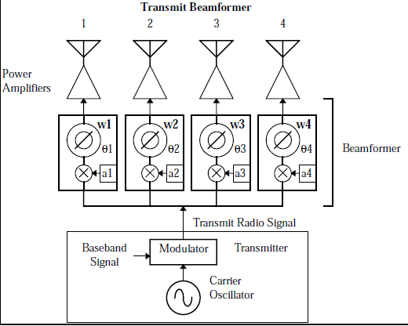 

(a) (b)

Fig. 4.2 (a) Multiple amplifier modules (b) combining multiple amplifier to combine radiated power modules units for increased transmitter power

An example of distributed feeding is the transmitter and antenna system at Indian MST radar at NARL, shown in Fig. 4.3

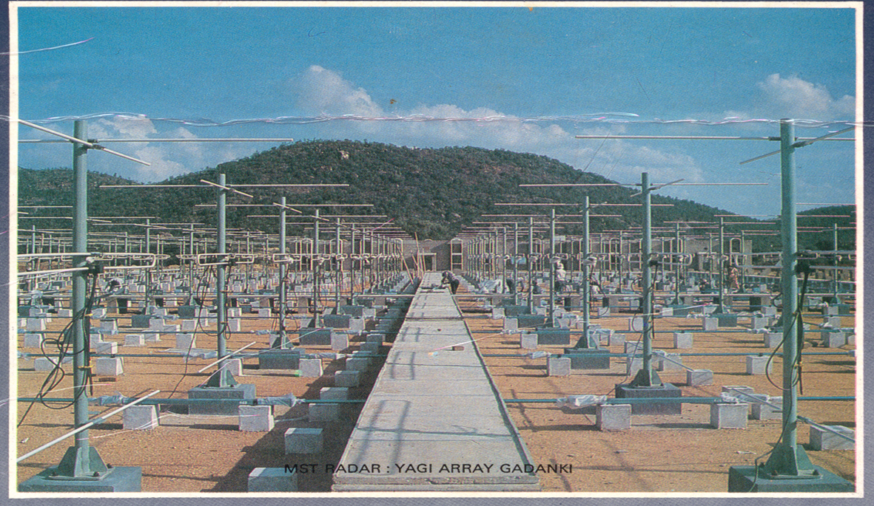

Fig. 4.3 The antennas array system of Indian MST radar. The transmitters are located cement constructions seen at the back

Vacuum devices must be used for high power RF and Microwave generation. These devices are categorized into following types.

1. **Devices with linear movement of charged particles:**
2. Devices which introduce with **electrostatic Control** (triodes, tetrodes and pentodes). Typical power 200 W to a few 100 kW and frequency from 400 KHz to 1000 MHz
3. Devices which introduce **small gap resonators or cavities**(Two and Multi-cavity klystrons and Reflex klystron). Typical 1 kW to 1 MW,frequency Range from S band to Terra Hertz Frequencies
4. Devices working with **electron beam and introduce Velocity modulation** (O- type of travelling wave tubes) Power 200 W to a few 10 s of kW and Frequency from 1 GHz to 100 GHz



Fig. 4.4 Schematic of Diode, Triode, tetrode and pentode

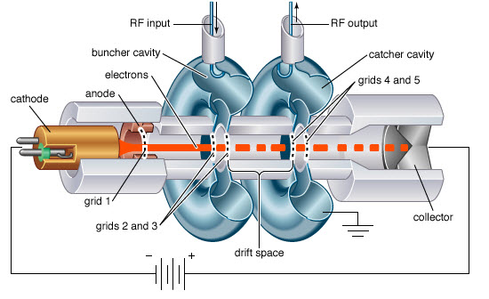 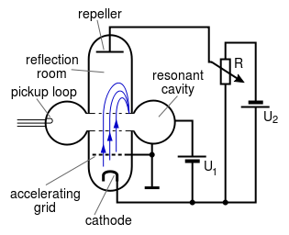

(a) (b)

Fig. 4.5 Schematic of (a) Two cavity Klystron and (b) Reflex Klystron

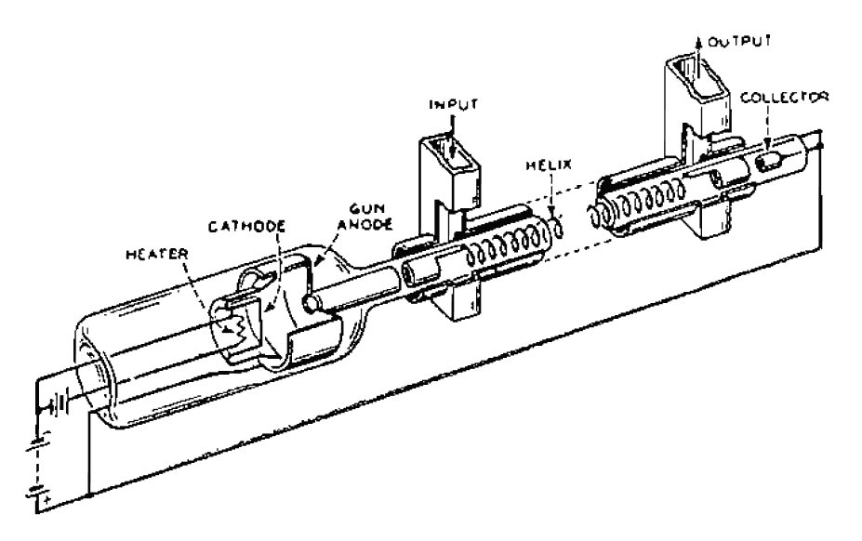 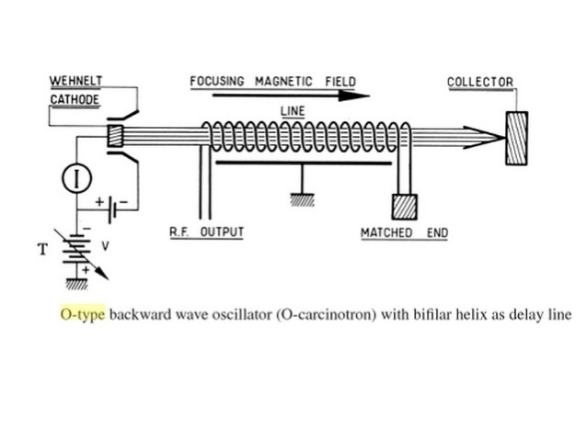

Fig. 4.6 Schematic of travelling wave tube (O–Type)

**2. Devices with curvilinear movement of charged particles:**

In this type of devices, the magnetic field is perpendicular to the movement of the electron. As a result, the electron path is curvilinear.

1. Magnetron: It has cylindrical construction, where cathode is centrally located in a rod shape and is heated so as to release electrons. The magnetic field is in the axial direction, parallel to the cathode and perpendicular to the electron movement. The electrons travel in a curvilinear path and resonate in the cavities carved in the anode located peripherally. Fig. 4.7 (a) and (b) illustrate this point. Fig. 4.8 shows construction of a typical magnetron. Typical power output of magnetron is in the range of 1 kW to 10 MW and the operating frequency range is from S band to to Ka Band
2. Carcinotron or M- type Backward wave Oscillator: In this arrangement, the electron travel through a periodic structure and are subjected to transverse magnetic field. Carcinotrons are available upto frequency of about 400 GHz. Fig. 4.9 shows the schematic of carcinotron.

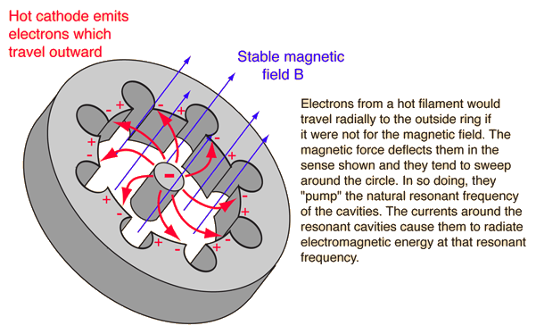 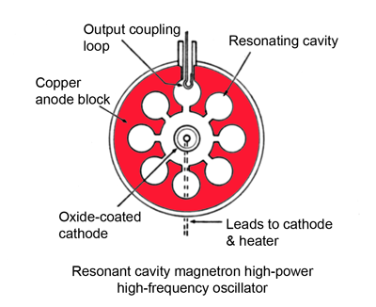

(a) Electron path in Magnetron (b) Cross section of Magnetron

Fig. 4.7 Schematic of travelling wave tube (O–Type)

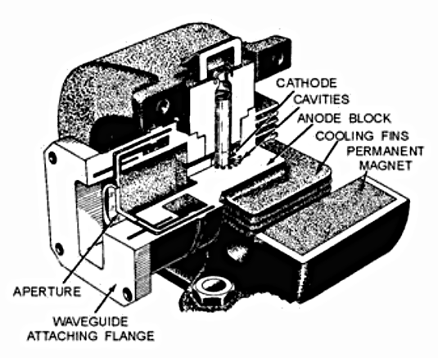

Fig. 4.8 Internal construction of a magnetron

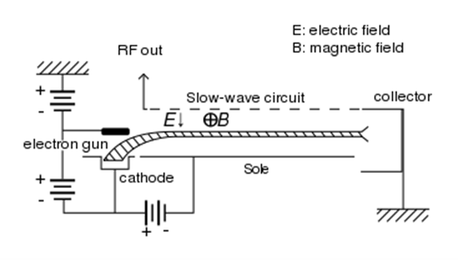

Fig. 4.9 Schematic of M-Type Backward wave Oscillator (Carcinotron)

* 1. **Sources for Terahertz frequencies, Sodars and Lidars**

The electromagnetic radiation terahertz range suffers a large loss due to atmospheric absorption. Therefore this band was unutilized for radar application. However, in the recent years some scanning devices operating on the radar principle have found some application in security domain. Fig. 4.10 shows a chart of the available technologies. An illustrative picture of internal structure of Gyratron is shown in Fig. 4.11.

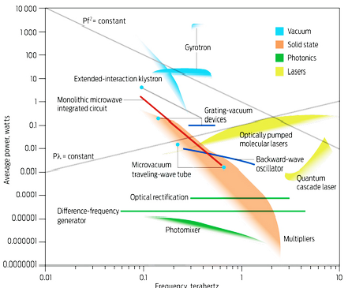

Fig. 4.10 Type of technologies used for the generation of Terra Hertz radiation.

(Source: http://spectrum.ieee.org/aerospace/military/the-truth-about-terahertz)

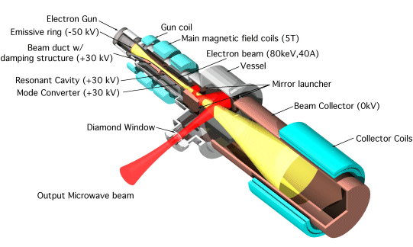

Fig. 4.11 Internal Structure of Gyratron

**LIDAR** are laser source instruments operate on the radar principles. They are effective in atmospheric studies (mainly on aerosols, pollutants etc), airborne biometric applications and 3-D imaging of land surfaces civil structures etc. Depending on applications, wavelengths between 250 nm to 1550 nm are used. As the energy requirement is low (approximately 4mJ per channel) semiconductor or fibre lasers are used. Typical lase source is shown in Fig 4.12

 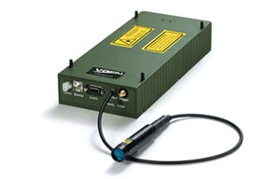

(a) (b)

Fig. 4.12 (a) Lidar transmitter with Frequency stabilized Nd:YAG Master Oscillator + Power Amplifier (MOPA) configuration with external frequency tripling by non-linear third harmonic generation (THG). (b)Ytterbium Pulsed Fiber Lasers

nternal Structure of Gyratron

**SODARs**: Wind velocities at lower altitudes are measured by Sodars. These systems use sound waves and operate on radar principle to estimate the wind velocity up to an altitude of about 7 km. Depending on the atmospheric layer, the transmission frequency is chosen between 100 Hz to 3 KHz. Single high power sources (1kW-3 kW) are compression drivers while sodar transmission is done with the help of an array of multiple piezo-electric sources. Fig. 4.13 shows pictures of both types of acoustic sources.

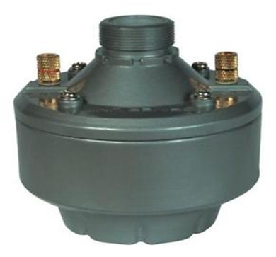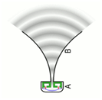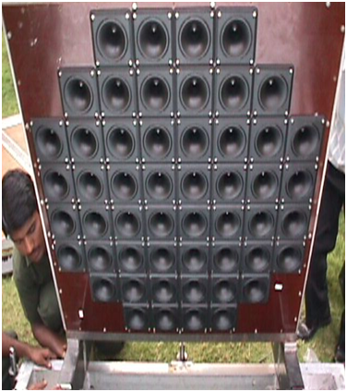

(a)

(b)

Fig. 4.12 (a) Compression Driver (b) Plased Array of Piezo-electric sources

* 1. **Phase Noise Considerations**

Doppler radars require that the transmitter frequency to be adequately stable. This quality is required for accurate Doppler estimation. This specification is expressed by phase noise. Fig. 4.13 illustrates the Frequency related specifications and the improvements due to phase locking techniques.

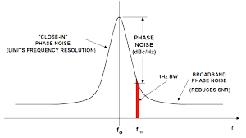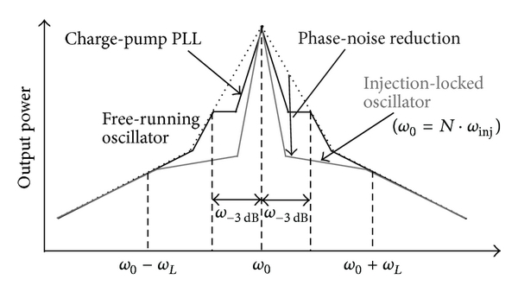

Fig. 4.13 (a) Defining phase noise (b) Phase noise levels for Locked oscillators

Higher efficiency is achieved when the power amplifier is operated in class C and higher classes. They lead to the generation of the harmonics; this means that transmitter operating at frequency ‘*f*’will also radiate frequency components at *2f*, *3f* etc. These are out of band components and generally there are restrictions on the power radiated. These restrictions are also defined in ‘watts.Hz-1’ or ‘V.m-1.Hz-1’.

* 1. **Duplexers and Circulators**

The transmitter is the illuminating source in for radars. Its function includes providing adequate radiation for the purpose. Naturally transmitter power is the most important specification. However, the leakage power of transmitter should be small enough so as not to disturb the receiver operation. This is computed using the ON-OFF ratio (see eq.4.1).

 (4.1)

It may be noted that the concept of ON-OFF ratio is valid for pulsed radars and it is basically the property of modulator. Most applications require more transmit receive isolation around > 100dB. This point is discussed in section 4.5. In such cases, Duplexers and Circulators are used. Fig. 4.14 illustrates these components. Fig. 4.14 also shows the location of blanking switch. This is an SPST switchis closed during the transmit time and provides additional isolation.

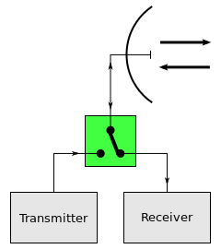

**Circulator**

**Duplexer**

Fig. 4.14 (a) Duplexer (b) Circulator

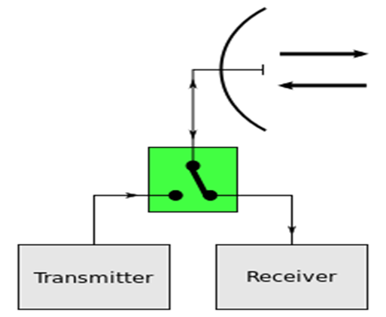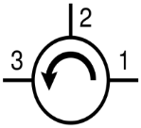

**Blanking Switch**

* 1. **Numerical problems**

Radar engineering is expected to know the use of transmitters in Radar systems. Following aspects important for this understanding:

1. Most suitable power amplifier technologiesfor the desired applications
2. Basic principles on which the transmitter operates

e.g. (i) Solid state :- Junction / transit time device etc.

(ii) Vacuum devices: Linear/ curvilinear; slow wave fast wave etc.

1. Purpose and specifications of functional blocks like modulator Harmonic filters etc.
2. Consequence of power amplifier stage; in terms of efficiency, generation of harmonics etc**.**
3. An atmospheric pulsed Doppler radar transmits peak power of 2 MW with a pulse width of 1 µs. The modulator ‘ON-off ratio’ is 90 dB and the Duplexer isolation is 70 dB. The LNA of the receiver saturates at 1 mW. is required to process -110dBm signal. Will this system require a blanking switch? If yes, what should be isolation? ( See Fig 4.14 (a) If the expected minimum Doppler frequency is 1 Hz, what should be the phase noise specifications? Will it relax the isolation requirements? How?
4. A fuel tank level measurement system is an FMCW radar operating in X band with a transmitter power of 1 watts. The receiver uses direct down conversion mixer diode with 1 the local oscillator power requirement of 1 mW. Can this radar be operated in mono-static mode (as shown in Fig4.14 (b)) with suitable circulator deriving the ‘local oscillator (LO)’ power from circulator leakage? If yes, what should be isolation of this circulator?

**Answers to the numerical problems**

1. 2 MW = 93 dBm and 1 mW= 0 dBm.

During the transmit period, leakage power is

93-70= 23 dBm. This is higher than the saturation power of 0dBm.

Hence the Blanking switch is required. (With isolation of > 23dBm)

During the receive period, the leakage power is

93-90-70= -67 dBm. In the Doppler analysis this signal will appear as DC.

We are interested in the moving targets having

Doppler frequency of > 1Hz and power > -110dB

The phase noise requirement will be better than -43dBc / Hz @ and offset of 1 Hz.

If the specification is better ( Say 50dBc / Hz@ offset of 1 Hz) then the Duplexer isolation up to 63 dB can be tolerated.

1. The circulator leaks a part of the lower to the isolated port (receiver port in this case)

This can be used as the LO power.

1 W = 30 dBm. Therefore, a circulator with isolation of 30dB will facilitate LO power of 1mW for mixing ( down conversion) in Monostatic FMCW radar.

**Chapter 5**

**Antennas Used in Radars**

Radar antennas are designed are designed according to the frequency of operation and the application. Generally, the radars require the antennas to be steerable and the radiation pattern with low side-lobe strength. One useful “rule of thumb expression relating antenna beam-width (in Degrees) physical dimensions are as follows:

 (5.1)

In ideal situations, 70 should be replaced by 50.76. However, considering aperture efficiencies we get 70 as a practical value. Here, cross dimension is the physical extent of the antenna aperture in direction perpendicular to the width. As an example, elevation beamwidth will depend on the antenna with in azimuth direction; and vice versa.

Antenna gain is sometimes expressed in terms of the beam widths in two perpendicular dimensions. As an example, if the elevation beam-width is Δθ and azimuth beam-width is Δφ, and both Δθ and Δφ are small, then the gain in radians is given by (5.2)..

 (5.2)

* 1. **Antenna Radiation Pattern**

Fig. 5.1 explains the terms used in reference to the antenna pattern

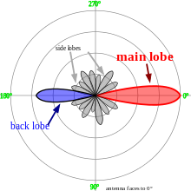

Fig 5.1 Antenna Radiation pattern.

The power in the intended direction is called the main lobe. The angular profile ( or the antenna radiation pattern in the plane of the electric vector is called the E-Plane pattern. This is the plane formed by the electric vector of the radiation and the direction of the propagation. Similarly, the plane along the magnetic vector (perpendicular to electric vector) is called the H-plane.

It is obvious that any radar application would require minimal power in the side-lobes. There is power loss in the side-lobes; but more important factor is that a target with higher ‘radar cross section’ would could give wrong interpretation of the target bearing (angular direction). Therefore, the power is required to be as low as possible.

Radar antenna are mainly of two types; namely

1. Single feed with reflector
2. 2-Dimensional array of many elements

Radiation pattern of an Antenna is a function of aperture illumination

* 1. **Effect of Aperture Illumination**

Radiation pattern of an Antenna is a function of aperture illumination. For a rectangular aperture with uniform aperture distribution, we get following equation

 (5.3)

Both the variables being independent, we could integrate individually to get

 (5.4)

It is seen that the pattern is in the form of Sinc Function. Grossly, it could be said that the radiation pattern is the Fourier transform of antenna aperture distribution.

* 1. **Array Antennas**

For better bearing estimation of the target the antenna beams must be narrow. This requires large antenna aperture. Such apertures are difficult to steer due to their large sizes. This limitation is addressed by designing array antennas. Array antenna is a set of many small radiating elements arranged in an array. Such arrays could be 1-D or 2-D also the elements could be arranged with regular or irregular spacing.

In order to address most of the relevant issues, it is sufficient to consider antennas with regular 2-D arrays. The expression for the radiation pattern could be looked as a discretized version of equation 5.3. Mathematical expressions for uniformly excited a one dimensional array would be as follows:

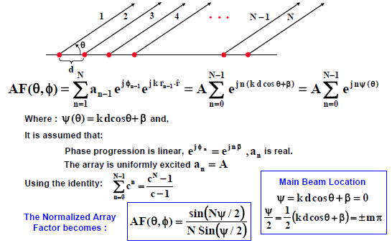

ϴ- Beam steer angle

Φ- cumulative phase (earlier element)

β- Elemental Phase

(in feed)

It is seen that the results give similar indications in favour of the Fourier transform approximation. As an example, Fig 5.1 shows the radiation pattern of an antenna array of 10 element with element spacing of λ/2. This makes aperture of 5λ. The first null shall occur at 1/5 radian, i.e 11.45 deg approximately.

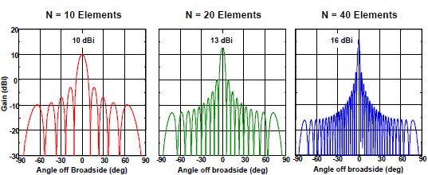

Fig 5.1 Antenna Radiation pattern.

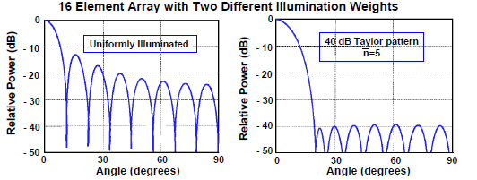

Fig 5.2 Obtaining Low side-lobes by using aperture distribution

Fig. 5.2 shows that if the antenna illumination pattern is made taylor distribution.



It can be seen that the sidelobe level could be brought down to a uniform lower level. However the central lobe becomes wide.

* 1. **Beam steering: mechanical and electronic**

Radar antennas are either steered

1. mechanically using a pedestal with (Azimuth over elevation arrangement, as shown in Fig. 5.3.

[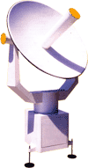](http://www.intermetsystems.com/)

Fig 5.3 Arrangement for mechanical steering

Or (b) Electronically by introducing the phase gradient in the adjacent elements of antenna array. Fig. 5.4 shows that the beam could be steered to angle θ by introducing the phase shift gradient of Δφ=2π/λ (d sin θ) where, d is the inter-element spacing.

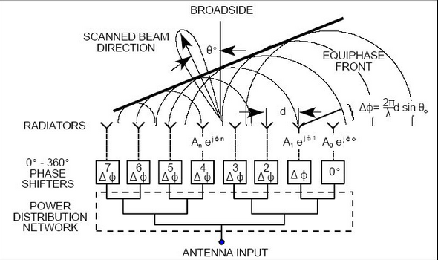

Fig 5.4 Electronic steering of a beam of antenna array

Similarly, two dimensional array can be steered in any off-vertical direction by introducing the phase shifts as shown in Fig 5.5.

This convention is used for a vertically looking array.

Z axis

H

G

E

Y axis

F

θy

D

θx

C

A

I

B

dx

dy

X axis

Fig 5.5 Electronic beam steering for 2-DS array radiating in vertical direction

The phase shift given to the element at the location (dx,dy) from trhe reference element. Is given by



(5.5)

Where,



And



For the horizontally looking array the convention of the symbols is slightly different.

The arrangement and the illustration for the expression is given in Fig. 5.6

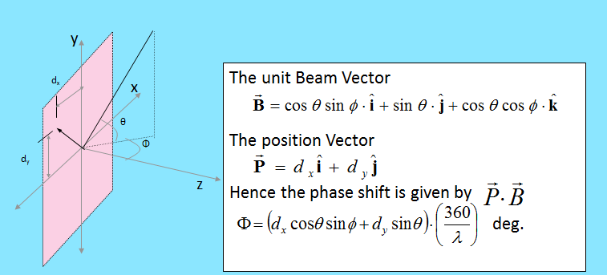

Fig 5.6 Electronic beam steering for 2-DS array radiating in horizontal direction

* 1. **Digital beam forming**

With the developments in digital technology, it has become possible to convert signal in a number which could be stored and remembered/ replicated. Modern radars take advantage of this capability and offer

1. Introduction of digitally introducing the phase shift and thereby changing the antenna beam direction.
2. Creating multiple receive beams! This facilitates detailed processing of multiple targets.

Fig. 5.7 and 5.8 illustrate the beam forming systems.

 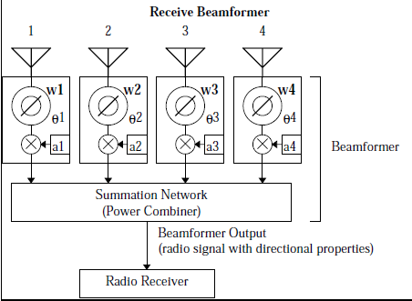

Fig 5.7 Formation of transmit and receive beam in conventional RF radar processor

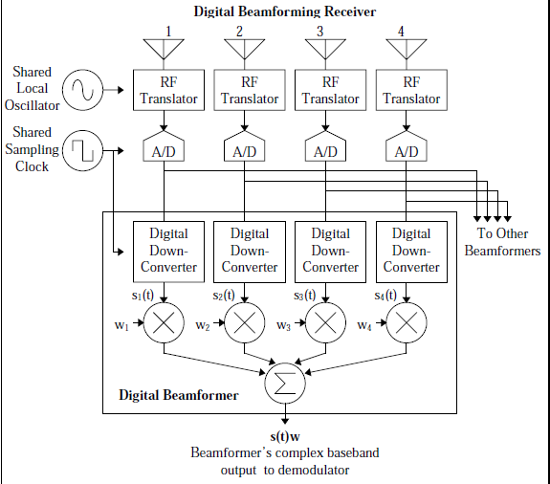

Fig 5.8 Digital beam forming on receive

* 1. **Applications**

Due to high speed sampling (upto a couple of GHz) all RF receiver processing is possible digitally. Especially the frequency mixing action can be implemented in terms of multiplications of numbers. The filtering also has been converted into digital computations. This capability has eliminated the non-ideal effects like amplitude and phase imbalance in quadrature action.

The capability of multiple beam forming gave a tremendous advantage for strategic applications. Modern radar performs “track while scan operation” where the transmit beam rotates for scanning and receiver maintains the record of multiple targets simultaneously updating the position every scan cycle.

* 1. **Numerical problems**

**Beam steering with phased array antenna (2 D)**

1. A two dimensional antenna-array operating at 15 GHz is set up on X-Y plane. This array has 63 elements (arranged in 7X9 formation as shown in Fig. below). All the elements are located on the cross-wire points on the grid of 1cm. This means that the individual element locations are (0,0), (0,1), (1,1) etc.(in cm) and fills up all the locations (i,j) where -3≤ i ≤+3 and -4≤ j ≤+4.

(a) Compute the orthogonal beam-widths (in X-Z plane and in Y-Z plane) if the beam is pointing at the Zenith

(b) In order to tilt the beam in the direction shown in the figure (approximately 53.130 with respect to Z axis), appropriately phased signals need to be fed to the radiating elements. What is the phase of the transmit signal to the element located at (3,4) with respect to the phase of element at (0,0) (reference)?

(c) Derive the expression to compute the phases of all the elements.

(Chose sign suitable convention to indicate the leading / lagging phases.)

P

Z

Y

53.130

P’(3,4,0)

o

X

2. Multiple Choice Questions (MCQs)

*Fig.2 Monostatic FMCW Radar with Circulator*

Transmitter

Receiver

Array

Antenna

Duplexer OR

T/R Switch

Blanking Switch

Transmitter

Receiver with Single port Mixer

*Fig.1 Monostatic pulsed Radar with Duplexer*

Array Axis

Antenna

Beam

600

900

Broadside beam

1. The radars shown in Fig1 and Fig.2 operate at 1.5 GHz and 10 GHz respectively. Both the radars use a linear broad-side phased array antenna is used (Broad side🡺 direction perpendicular to the array axis). This is main lobe or the intended direction of radiation (dark grey beam in Fig. 1 and Fig. 2). What must be maximum distance between adjacent radiating elements so that no grating lobes are observed? This means that the radiated power in any other direction should not add equal to that of main lobe.
2. 20 cm, 3 cm (b) 7.5 cm, 1.5 cm (c)20 sin(450)cm, 3sin(450)cm (d) 10cm, 2.1cm

(ii) A linear phased array has inter-element distance of ‘0.5 λ’. This array is required to steer the beam at direction making an angle of 600 with the array direction; as shown by the faint grey beam in Fig.2. What should be the phase difference between the adjacent elements?

(a) 1350  (b) (90√3)0 (c) 450 (d) 900

**Answers to the numerical problems**

1.

(a) Beam widths when pointed at Zenith

The antenna dimensions are 3.5λX 4.5λ. We use the expression 🡺 BW (deg)= 70 λ/D

Hence the beam width in X-Z plane is (70/3.5) = 200

And beam width in Y-Z plane is (70/4.5) = 15.5560

1. 53.130 tilt from Zenith (δ, say= 90-ϴ, where ϴ is elevation angle)

Diagram shows that the perpendicular drops on X-Y plans at P’(3,4,0)

Phase to the element at (0,0) is taken as reference= 00.,

The inter-element distance (OP) is 5cm.

Phase shift element at (3,4) = (dX Sin 53.130)/λ X360= 5X 0.8/2 X360 = 7200,

So same phase as the element at O !.

(c) Let the co-ordinates of the element be (a,b) so that the position vector is = **a*i*+b*j***.

The beam shown in the diagram makes azimuth angle (ϕ, say) = 53.130. However, the angle ϕ shall have different value in general.

Let **û** be the unit vector in the direction of the beam.

**û** = **Sin**δ **Cos** ϕ***i* +**= **Sin**δ **Sin**ϕ ***j***+ **Cos δk**=0.48 ***i* +**.0.64***j*** +0.6*k*.

WE take the scalar product to compute the path difference

Path difference (P) =0.48**a** + 0.64**b**. Hence the angle (deg)= P/ λ X 360

1. **MCQ**

**(i) (a)**When the main lobe is at 90 degrees to the axis, in the limiting case, the grating lobe appear along the axis. The radiations from adjacent elements add in phase along the axis when the **inter-element distance = λ!** (the max separation).For 1.5 GHz and 10 GHz, λ=20cm and 3 cm respectively.

**(ii) (d)** 600 w.r.t. axis is same as 300 from the perpendicular to axis (bore-sight) direction. The required path difference is **= 0.5 λ sin (300)** = 0.25 **λ,** so phase difference is **900**

**Chapter 6**

**Receivers**

* 1. **Receiver Protection**

Radar receivers are expected to be capable of detecting and analysing very small signals thereby exhibiting sensitivity towards very weak target echoes. As a result, the electronics use devices which are susceptible to damage if exposed to high power inputs. Earlier chapters present methods to protect receiver from the transmitter power with the help of Duplexers blanking switches etc. Additionally, protecting devices must be used to prevent transients and spurious signals from other sources.

This process involves computation of energy of the transients. This is estimated by consuming maximum power (or voltage) incident on the receiver and the time duration. Appropriate ‘transient absorber’ (or spark) gaps devices are used at the input of the receiver.

Transient absorbers have action like Zeener diode and are rated to absorb certain amount of power. On the other hand, spark gaps are precision gap modules. Current flows through these gaps if the applied voltage is higher than the designed level. Thus the receiver can be protected to limited (known) attack of excess voltage as well as power.

* 1. **Matched filter detection**

Main function of the receiver is to detect and discriminate the radar echo against other unwanted signals like clutter interference and noise. Classical old time approach has been to ensure that echo strength is above the noise level. However, the signal is enhanced only if complete signal waveform is gathered. This is done by correlating the replica of the transmitted signal waveform with the echo. Such filter is called “matheched filter. In other words, The matched filter is the optimal linear filter for maximizing the signal to noise ratio (SNR) in the presence of additive stochastic noise. This is the optimum technique of enhancing the desired signal. Fig. 6.1 shows the linear system schematic for the matched filter.



Fig. 6.1 Matched filteras LTI system

The description of the matched filter is given by

 (6.1)

Therefore,  (6.2)

In other words, Matched filter is the system whose impulse response is the time reverses version of the transmit waveform. Fig 6.2 shows the enhancement of the rectangular pulse by correlation of the replica.



Fig. 6.2 Enhancement of rectangular pulse by correlation (matched filter action)

* 1. **Types of radar receivers**

A quick look at the earlier radar gives the following

1. **Crystal Video Receiver**



Fig. 6.3 Crystal video receiver

1. **TRF receiver**: Just add RF amplifier to the crystal detector



Fig. 6.4 Tuned Radio Frequency receiver

1. Super heterodyne receiver. This approach has one or more frequency conversions to ensure that the receiver caters for exactly the desired bandwidth.

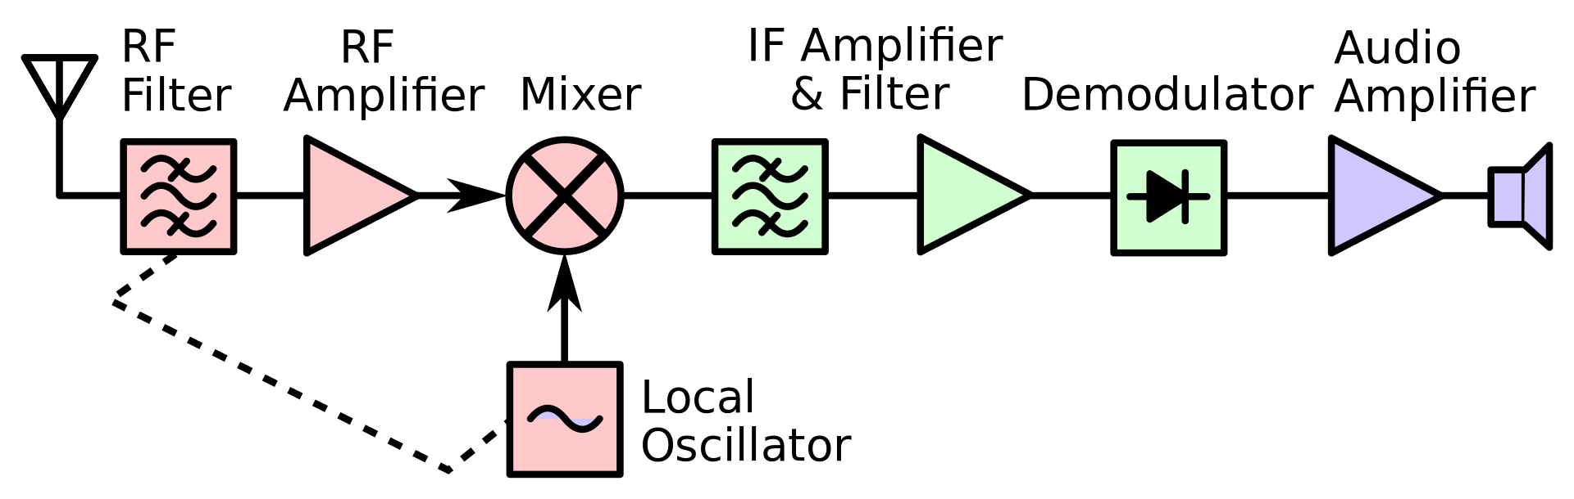

Fig. 6.5 heterodyne receiver

* 1. **Digital receivers**

Fig. 6.6 shows a typical radar receiver. Advancements in digital technology makes it possible to implement the functionality of the modules operating up to IF frequencies digitally. This means mixing, filtering and amplification is implemented in terms of mathematical computations. This approach eliminates the amplitude imbalances and phase imbalances in I and Q channels. This also removes non-linearity and aging effects, which used to be observed in the analog systems. There are two limitations of the digital systems: (i) that it adds quantization noise due to discrete nature of the ADC. And (ii) Frequency aliasing effects due to finite sampling rate. However, by careful design, it is possible to make the effects insignificant.

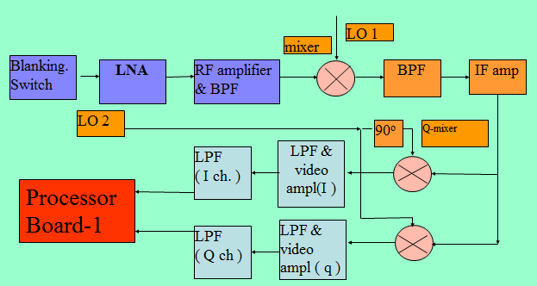

Digital receiver

Fig. 6.6 Super heterodyne receiver: Digital implementation in IF stages

* 1. **Pulse compression**

The main motive of the receiver signal processor is achieving maximum possible signal to noise ratio (SNR). Given other system parameters same, the SNR can be improved by increasing the pulsed transmitted power or to reduce the noise. The transmitted power can be increased by two ways:

1. Increasing the peak power of the radar pulse: This option increases the cost and consumes more power. Therefore, there are practical limitations.
2. Having a broad pulse width and detecting the signal using ‘matched filter’: This approach deteriorates the range resolution. (as the range resolution is inversely proportional to the pulse width (τ).

Pulse compression techniques are used to mitigate the second method. In this technique, the transmitted signal is coded during the pulse. Biphase coding is the most popular technique. In order to improve the pulse power by a factor of ‘n’, a biphase code of n bits is used. This means the phase of the transmit signal is changed with a time resolution of (τ/n). Fig. 6.7 shows an example of usage of Bi-phase code.

t = 2d **/**c

PRP

τ

Fig. 6.7 Pulse compression using barker code

Coded Tx pulse

Echo (coded)

Table 6.1 Barker codes:

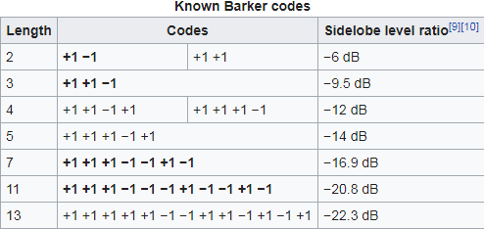

It can be seen that the implementation of matched filter in form of correlation receiver shows the enhancement of the signal by five times, as desired. The location of the peak can be determined with a resolution equal to the sub-pulse-width (τ). Therefore it is possible to achieve the resolution corresponding to ‘τ’.The other peaks are of the magnitude 1. These smaller peaks are also known as ‘range side-lobes’. Such codes are known as Barkar codes. There are 13 such code sequences (see table 6.1)

The transmission of FMCW radars is also sometimes referred as pulse compression

* 1. **Signal enhancement techniques**

The radars used for slow observing targets have expected maximum Doppler frequencies much lower than the PRF. In this case these radars can take advantage of the signals by simply adding the echoes of a few consecutive pulses. This process is called coherent integration. Fig. 6.8 shows the coherent processing scheme used in pulsed Doppler radars

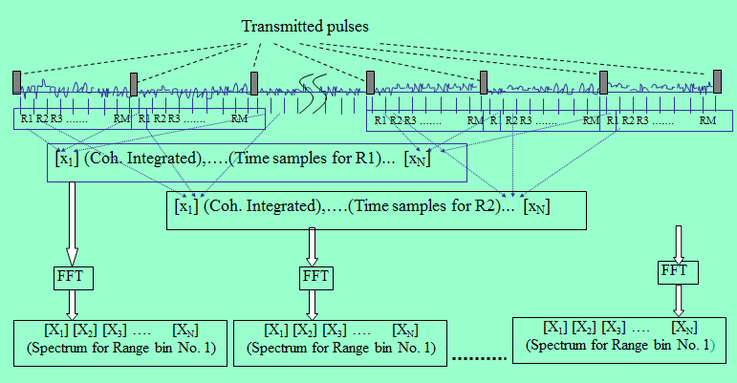

Fig. 6.8 Coherent integration followed by FFT computation

Coherent integration gives SNR enhancement by a factor of ‘n’; where ‘n’ is the number of pulses integrated. This is straight forward as the signal power becomes n2 times when ‘n’ identical amplitudes are added. Noise is a random variable. Therefore, the power (or variance) of n samples variables becomes ‘n’ times. As a result, the SNR improves by a factor of ‘n’

We have seen that echoes of multiple pulses could be integrated, while analyzing slower targets. In this case, advanced pulse compression codes could be used. Fig. 6.9 shows the usage of complementary code. It is seen that the range- side lobes are absent and the advantage of all the sub pulses is achieved.

t = 2d **/**c

Echo (code-2)

Tx (Code-2)

Tx (Code-1)

PRP

Echo (code-1)

**τ**

Sub-pulse-width

Pulse

Width

Correlation of echoes with corresponding pulses and point-by point addition of correlation sequence

Fig. 6.9 Pulse compression using complementary code

In case of atmospheric applications, the target is stationary or very slowly moving. This situation offers an opportunity to integrate the power spectrum. The point to point addition of Power spectral components give SNR improvement by a factor of square-root of ‘n’ (=√n)

* 1. **Numerical Problems**

1. **Matched filter and Pulse Compression**

(a) What is a matched filter? What purpose does it serve in radar receivers?

The range resolution of the radar can be increased by performing ‘bi-phase’ coding in the transmit pulse. The received signal is processed by performing correlation with the same bi-phase sequence of the transmit code. This is also called pulse ‘pulse compression’.

Consider a 10 microsecond pulse is coded with a 5 bit code: “ +1,-1,+1,+1,+1”

(b) Draw transmit-code showing schematic waveform of bi-phase code

(c) What will be the range resolution of this system?

(d) What will be the nearest distance (blind range) whose echo can be processed?

(e) Show the correlation output when the echo is correlated in the base-band signal

(in other words, draw the autocorrelation function) and show the range side-lobes. At what distance do they appear from the target?

(f) What will be the ratio of range side-lobe magnitude compared to the main lobe?

**MCQ**

1. A pulsed radar uses a ‘7 bit Barker code’. The receiver performs correlation matched to the transmitted code. Due to this, an echo of a single target generates a peak at the target location and a few small peaks in the few adjacent ranges (known as range side-lobes). Assuming completely noiseless environment, what will be the number of false echoes and their relative power compared to the power of the target echo?

(a) six range-side-lobes of power 1/7 of the target signal

(b) Six range-side-lobes of power 1/49 of the target signal

(c) Two range side-lobes of 1/7 power and 4 range side-lobes of 1/49 power.

(d) Matched filter implementation does not lead to range side-lobes

**Answers to the numerical problems**

Q6 (a) Matched filter is a ‘Linear Time Invariant (LTI)’ filter

Whose impulse response is the time reversed waveform of the transmit pulse.

OR Which correlates the received signal with replica of the transmit signal.

OR Mathematically, the impulse response is 

(Where, K is any arbitrary constant and N0 is the noise power)

OR the transfer function is



It maximizes the signal SNR

🡺 Thereby maximizing the ‘probability of detection’/ detectability

(b)

Transmit-Pulse



2μs

+1 -1 +1 +1 +1

10μs

(c) Sub-pulse duration is 2μs. Range resolution (= cτ/2 = 3 X108 X 2X10-6/ 2=300m)

(d) This radar cannot process the echoes arriving before completing the transmit pulse. It takes 10μs. It corresponds to 1500 m or 1.5 km. ( blind range) )

1. X range/c= 10 μs 🡺 Range= 10X10-6X3 X108/2=1500m)

(e) See Fig. 6.7. There are 4 range side lobes.

They occur at ±600m and ±1200 m from the target range

(f) The range side lobes will be 1/5 of the main in magnitude and

1/25 of the main lobe in power (13.9 dB)

**MCQ:**

1. **(b)** Barkar code generates Amplitude of n at the target location and range side-lobes of amplitude 1 at alternate range bins.

Total 7 peaks. 1(main)+ 6 ( rangeside-lobes). Amplitude ratio = 7. 🡺 **Power ratio of 49**.

**Appendix 2**

**Electronic Power Amplifiers**

(Different Classes of operation and their efficiencies)

**(Ref:** [**https://www.electronics-tutorials.ws/amplifier/amplifier-classes.html**](https://www.electronics-tutorials.ws/amplifier/amplifier-classes.html)**)**

**https://en.wikipedia.org/wiki/Power_amplifier_classes gives some information on E and H classes**

**The amplifiers are used for the amplification of the signals are operating in the different classes according to the system requirements.**

The main operating characteristics of an ideal amplifier are linearity, signal gain, efficiency and power output but in real world amplifiers there is always a trade off between these different characteristics.

Generally, large signal or power amplifiers are used in the output stages of audio amplifier systems to drive a loudspeaker load. A typical loudspeaker has an impedance of between 4Ω and 8Ω, thus a power amplifier must be able to supply the high peak currents required to drive the low impedance speaker.

One method used to distinguish the electrical characteristics of different types of amplifiers is by “class”, and as such amplifiers are classified according to their circuit configuration and method of operation. Then **Amplifier Classes** is the term used to differentiate between the different amplifier types.

*Amplifier Classes* represent the amount of the output signal which varies within the amplifier circuit over one cycle of operation when excited by a sinusoidal input signal. The classification of amplifiers range from entirely linear operation (for use in high-fidelity signal amplification) with very low efficiency, to entirely non-linear (where a faithful signal reproduction is not so important) operation but with a much higher efficiency, while others are a compromise between the two.

Amplifier classes are mainly lumped into two basic groups. The first are the classically controlled conduction angle amplifiers forming the more common amplifier classes of A, B, AB and C, which are defined by the length of their conduction state over some portion of the output waveform, such that the output stage transistor operation lies somewhere between being “fully-ON” and “fully-OFF”.

The second set of amplifiers are the newer so-called “switching” amplifier classes of D, E, F, G, S, T etc, which use digital circuits and pulse width modulation (PWM) to constantly switch the signal between “fully-ON” and “fully-OFF” driving the output hard into the transistors saturation and cut-off regions.

The most commonly constructed amplifier classes are those that are used as audio amplifiers, mainly class A, B, AB and C and to keep things simple, it is these types of **amplifier classes** we will look at here in more detail.

**Class A Amplifier**

**Class A Amplifiers** are the most common type of amplifier class due mainly to their simple design. Class A, literally means “the best class” of amplifier due mainly to their low signal distortion levels and are probably the best sounding of all the amplifier classes mentioned here. The class A amplifier has the highest linearity over the other amplifier classes and as such operates in the linear portion of the characteristics curve.

Generally class A amplifiers use the same single transistor (Bipolar, FET, IGBT, etc) connected in a common emitter configuration for both halves of the waveform with the transistor always having current flowing through it, even if it has no base signal. This means that the output stage whether using a Bipolar, MOSFET or IGBT device, is never driven fully into its cut-off or saturation regions but instead has a base biasing Q-point in the middle of its load line. Then the transistor never turns “OFF” which is one of its main disadvantages.

**Class A Amplifier**

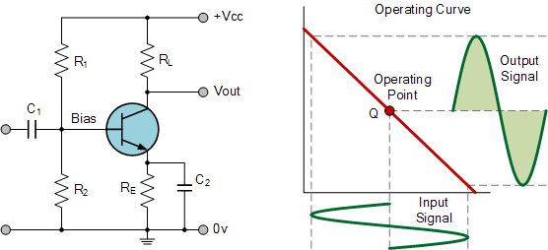

To achieve high linearity and gain, the output stage of a class A amplifier is biased “ON” (conducting) all the time. Then for an amplifier to be classified as “Class A” the zero signal idle current in the output stage must be equal to or greater than the maximum load current (usually a loudspeaker) required to produce the largest output signal.

As a class A amplifier operates in the linear portion of its characteristic curves, the single output device conducts through a full 360 degrees of the output waveform. Then the class A amplifier is equivalent to a current source.

Since a class A amplifier operates in the linear region, the transistors base (or gate) DC biasing voltage should by chosen properly to ensure correct operation and low distortion. However, as the output device is “ON” at all times, it is constantly carrying current, which represents a continuous loss of power in the amplifier.

Due to this continuous loss of power class A amplifiers create tremendous amounts of heat adding to their very low efficiency at around 30%, making them impractical for high-power amplifications. Also due to the high idling current of the amplifier, the power supply must be sized accordingly and be well filtered to avoid any amplifier hum and noise. Therefore, due to the low efficiency and over heating problems of Class A amplifiers, more efficient amplifier classes have been developed.

**Class B Amplifier**

**Class B amplifiers** were invented as a solution to the efficiency and heating problems associated with the previous class A amplifier. The basic class B amplifier uses two complimentary transistors either bipolar of FET for each half of the waveform with its output stage configured in a “push-pull” type arrangement, so that each transistor device amplifies only half of the output waveform.

In the class B amplifier, there is no DC base bias current as its quiescent current is zero, so that the dc power is small and therefore its efficiency is much higher than that of the class A amplifier. However, the price paid for the improvement in the efficiency is in the linearity of the switching device.

**Class B Amplifier**

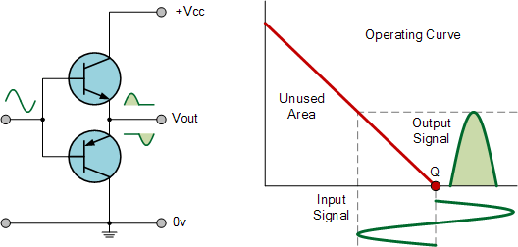

When the input signal goes positive, the positive biased transistor conducts while the negative transistor is switched “OFF”. Likewise, when the input signal goes negative, the positive transistor switches “OFF” while the negative biased transistor turns “ON” and conducts the negative portion of the signal. Thus the transistor conducts only half of the time, either on positive or negative half cycle of the input signal.

Then we can see that each transistor device of the class B amplifier only conducts through one half or 180 degrees of the output waveform in strict time alternation, but as the output stage has devices for both halves of the signal waveform the two halves are combined together to produce the full linear output waveform.

This push-pull design of amplifier is obviously more efficient than Class A, at about 50%, but the problem with the class B amplifier design is that it can create distortion at the zero-crossing point of the waveform due to the transistors dead band of input base voltages from -0.7V to +0.7.

We remember that the transistor takes a base-emitter voltage of about 0.7 volts to get a bipolar transistor to start conducting. Then in a class B amplifier, the output transistor is not “biased” to an “ON” state of operation until this voltage is exceeded.

This means that the the part of the waveform which falls within this 0.7 volt window will not be reproduced accurately making the class B amplifier unsuitable for precision audio amplifier applications.

To overcome this zero-crossing distortion (also known as Crossover Distortion) class AB amplifiers were developed.

**Class AB Amplifier**

As its name suggests, the **Class AB Amplifier** is a combination of the “Class A” and the “Class B” type amplifiers we have looked at above. The AB classification of amplifier is currently one of the most common used types of audio power amplifier design. The class AB amplifier is a variation of a class B amplifier as described above, except that both devices are allowed to conduct at the same time around the waveforms crossover point eliminating the crossover distortion problems of the previous class B amplifier.

The two transistors have a very small bias voltage, typically at 5 to 10% of the quiescent current to bias the transistors just above its cut-off point. Then the conducting device, either bipolar of FET, will be “ON” for more than one half cycle, but much less than one full cycle of the input signal. Therefore, in a class AB amplifier design each of the push-pull transistors is conducting for slightly more than the half cycle of conduction in class B, but much less than the full cycle of conduction of class A.

In other words, the conduction angle of a class AB amplifier is somewhere between 180oand 360o depending upon the chosen bias point as shown.

**Class AB Amplifier**

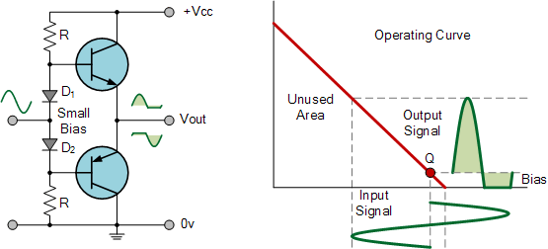

The advantage of this small bias voltage, provided by series diodes or resistors, is that the crossover distortion created by the class B amplifier characteristics is overcome, without the inefficiencies of the class A amplifier design. So the class AB amplifier is a good compromise between class A and class B in terms of efficiency and linearity, with conversion efficiencies reaching about 50% to 60%.

**Class C Amplifier**

The **Class C Amplifier** design has the greatest efficiency but the poorest linearity of the classes of amplifiers mentioned here. The previous classes, A, B and AB are considered linear amplifiers, as the output signals amplitude and phase are linearly related to the input signals amplitude and phase.

However, the class C amplifier is heavily biased so that the output current is zero for more than one half of an input sinusoidal signal cycle with the transistor idling at its cut-off point. In other words, the conduction angle for the transistor is significantly less than 180 degrees, and is generally around the 90 degrees area.

While this form of transistor biasing gives a much improved efficiency of around 80% to the amplifier, it introduces a very heavy distortion of the output signal. Therefore, class C amplifiers are not suitable for use as audio amplifiers.

**Class C Amplifier**

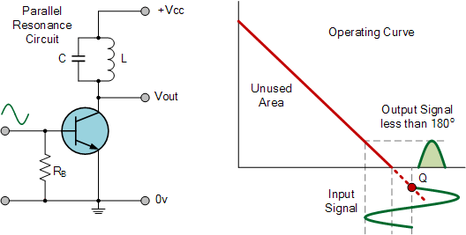

Due to its heavy audio distortion, class C amplifiers are commonly used in high frequency sine wave oscillators and certain types of radio frequency amplifiers, where the pulses of current produced at the amplifiers output can be converted to complete sine waves of a particular frequency by the use of LC resonant circuits in its collector circuit.

**Amplifier Classes Summary**

Then we have seen that the quiescent DC operating point (Q-point) of an amplifier determines the amplifier classification. By setting the position of the Q-point at half way on the load line of the amplifiers characteristics curve, the amplifier will operate as a class A amplifier. By moving the Q-point lower down the load line changes the amplifier into a class AB, B or C amplifier.Then the class of operation of the amplifier with regards to its DC operating point can be given as:

**Amplifier Classes and Efficiency**

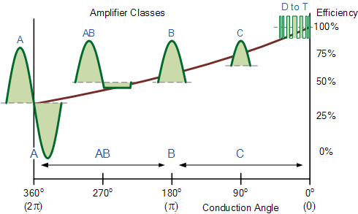

As well as audio amplifiers there are a number of high efficiency **Amplifier Classes** relating to switching amplifier designs that use different switching techniques to reduce power loss and increase efficiency. Some amplifier class designs listed below use RLC resonators or multiple power-supply voltages to reduce power loss, or are digital DSP (digital signal processing) type amplifiers which use pulse width modulation (PWM) switching techniques.

**Other Common Amplifier Classes**

* Class D Amplifier – A Class D audio amplifier is basically a non-linear switching amplifier or PWM amplifier. Class-D amplifiers theoretically can reach 100% efficiency, as there is no period during a cycle were the voltage and current waveforms overlap as current is drawn only through the transistor that is on.
* The class-E/F amplifier is a highly efficient tuned switching power amplifier used at radio frequencies. It uses a single-pole switching element and a tuned reactive network between the switch and the load. The circuit obtains high efficiency by only operating the switching element at points of zero current (off to on switching) or zero voltage (off to on switching) which minimizes power lost in the switch, even when the switching time of the devices is long compared to the frequency of operation.
* Class F Amplifier – Class-F amplifiers boost both efficiency and output by using harmonic resonators in the output network to shape the output waveform into a square wave. Class-F amplifiers are capable of high efficiencies of more than 90% if infinite harmonic tuning is used.
* Class G Amplifier – Class G offers enhancements to the basic class AB amplifier design. Class G uses multiple power supply rails of various voltages and automatically switches between these supply rails as the input signal changes. This constant switching reduces the average power consumption, and therefore power loss caused by wasted heat.
* Class I Amplifier – The class I amplifier has two sets of complementary output switching devices arranged in a parallel push-pull configuration with both sets of switching devices sampling the same input waveform. One device switches the positive half of the waveform, while the other switches the negative half similar to a class B amplifier. With no input signal applied, or when a signal reaches the zero crossing point, the switching devices are both turned ON and OFF simultaneously with a 50% PWM duty cycle cancelling out any high frequency signals.

To produce the positive half of the output signal, the output of the positive switching device is increased in duty cycle while the negative switching device is decreased by the same and vice versa. The two switching signal currents are said to be interleaved at the output, giving the class I amplifier the named of: “interleaved PWM amplifier” operating at switching frequencies in excess of 250kHz.

* Class S Amplifier – A class S power amplifier is a non-linear switching mode amplifier similar in operation to the class D amplifier. The class S amplifier converts analogue input signals into digital square wave pulses by a delta-sigma modulator, and amplifies them to increases the output power before finally being demodulated by a band pass filter. As the digital signal of this switching amplifier is always either fully “ON” or “OFF” (theoretically zero power dissipation), efficiencies reaching 100% are possible.
* Class T Amplifier – The class T amplifier is another type of digital switching amplifier design. Class T amplifiers are starting to become more popular these days as an audio amplifier design due to the existence of digital signal processing (DSP) chips and multi-channel surround sound amplifiers as it converts analogue signals into digital pulse width modulated (PWM) signals for amplification increasing the amplifiers efficiency. Class T amplifier designs combine both the low distortion signal levels of class AB amplifier and the power efficiency of a class D amplifier.

We have seen here a number of classification of amplifiers ranging from linear power amplifiers to non-linear switching amplifiers, and have seen how an amplifier class differs along the amplifiers load line. The class AB, B and C amplifiers can be defined in terms of the conduction angle, θ as follows:

**Amplifier Class by Conduction Angle**

|  |  |  |
| --- | --- | --- |
| Amplifier Class | Description | Conduction Angle |
| Class-A | Full cycle 360o of Conduction | θ = 2π |
| Class-B | Half cycle 180o of Conduction | θ = π |
| Class-AB | Slightly more than 180o of conduction | π < θ < 2π |
| Class-C | Slightly less than 180o of conduction | θ < π |
| Class-D to T | ON-OFF non-linear switching | θ = 0 |